

Agenda for IIC Council Meeting – Quarter 4
Minutes of Meeting
Date: 21-06-2025
Time: 12:00 PM to 2:00 PM
Venue: Library
President: Dr. Vasu B A, Principal
Convener: Dr. Roopa Shettigar, Associate Professor, MBA Dept

Office Bearers:
- President: Dr. Vasu B A (Principal & Director)
- Vice President: Mr. Shivakumar U Ghanachari (HOD, Dept. of English)
- Convener: Dr. Roopa Shettigar
- Start-up Activity Coordinator: Ms. Divya Jairam (Assistant Professor, BBA)
- ARIIA Coordinators: Mrs. Prithvi Heggade (BCom HOD), Dr. Prashanth Kumar (M.Com HOD)
- Internship Activity Coordinator: Mrs. Ramya Sheshadri (Training & Placement Head)
- IPR Coordinator: Dr. Nagalakshmi (B.Sc. Forensic HOD)
- Social Media Coordinator: Mr. Sujeesh Surendran
- NIRF Coordinator: Mr. Vibin Krishnan (IQAC Head)
- Innovation Activity Coordinator: Mr. Yatish Kumar (BCA HOD), Dr. Suchitha S (Professor, MCA)
- YUKTI Coordinator: Mr. Chethan (BCA Dept) & Mr. Yuvaraj Halage (MBA HOD)
- KAPILA Coordinators: Dr. Roopa Shettigar (MBA), Dr. Shreemathi Giri (BSc), Dr.Menaka C (MCA HOD)
- NISP Coordinator: Mr. Vibin Krishnan
- Pre-incubation/Incubation Coordinator: Dr. Shreemathi Giri (BSc)
- Members-
  - Ms. Jennifer, Assistant Professor, B. Com
  - Ms. Kumuda, Assistant Professor, BA
  - Ms. Chandana S Naik, Assistant Professor, B.Sc
  - Ms. Theertha, Assistant Professor, B. Sc Forensic
  - Mr. Angel Chakraborty, Assistant Professor, MBA
  - Ms. Shambhavi B R, Assistant Professor, M.Com
  - Mrs. Ramya H S (BA HOD)
  - All language Professors

Attendees:
- All HODs of respective departments
- One IIC Representative from each department

Meeting Agenda & Summary
- Welcome Address & Opening Remarks
The meeting commenced with an opening note from the IIC President who emphasized the importance of strategic innovation and calendar compliance.
- Discussion on IIC Calendar of Events (Quarter 4 – June to August 2025):
  - Departments were instructed to plan and finalise their Quarter 4 events aligned with the IIC mandate.
  - Discussion was held on mandatory activities to be carried out under various themes: Innovation, Start-up, IPR, Incubation, and Entrepreneurship.
  - Calendar activities must include key observance days like Innovation Day, National Entrepreneurship Day, etc.
  - All departments must fill in the Google Calendar with specific event dates.
- Documentation and Reporting Requirements:
  - Mandatory submission of a detailed report within 3 days of event completion by each department.
  - Reports should include: event report, images, video links, participant list, and geo-tagged photos.
  - Upload reports to the designated Google Drive folder: IIC Reports Folder Link
- Google Calendar Entries:
  - Departmental IIC representatives are required to fill in the dates of the planned events in the shared Google Calendar Link.
  - This will help with real-time monitoring of activities.
- Monitoring and Evaluation:
  - All department IIC representatives will share 5 to 10 students’ information (Interested Only). i.e Name, Year/ Semester, Contact No. and Email ID to fill in their details in IIC as a student coordinator.
  - Activities will be evaluated based on relevance, quality of documentation, and timely submission.
  - Coordinators will maintain a consolidated report for submission to the central IIC platform.
- Roles and Responsibilities:
  - HODs to ensure compliance and event execution.
  - Department IIC Representatives to coordinate and communicate updates.
  - Faculty Members to actively organise and participate in activities.
- Innovation Ambassador Training:
  - All nominated faculty must complete the Innovation Ambassador training as per AICTE/MHRD instructions.
  - Faculty who have received mail from iic.mhrd@aicte-india.org are instructed to complete registration and certification.
- Additional Key Observance Days (to be planned & reported):
  - Innovation Day
  - National Education Day
  - National Entrepreneurship Day
  - National Science Day
  - National Start-up Day
  - National Youth Day
  - National Energy Conservation Day
  - National Pollution Control Day

Action Points Post-Meeting:
- All departments to finalize events and fill the Google Calendar by 30th June 2025.
- Post-event report submission is compulsory within 2 days of activity.
- Department IIC representatives to regularly update reports in the Google Drive folder.
- Coordinators to track activity progress monthly and ensure alignment with the IIC framework.

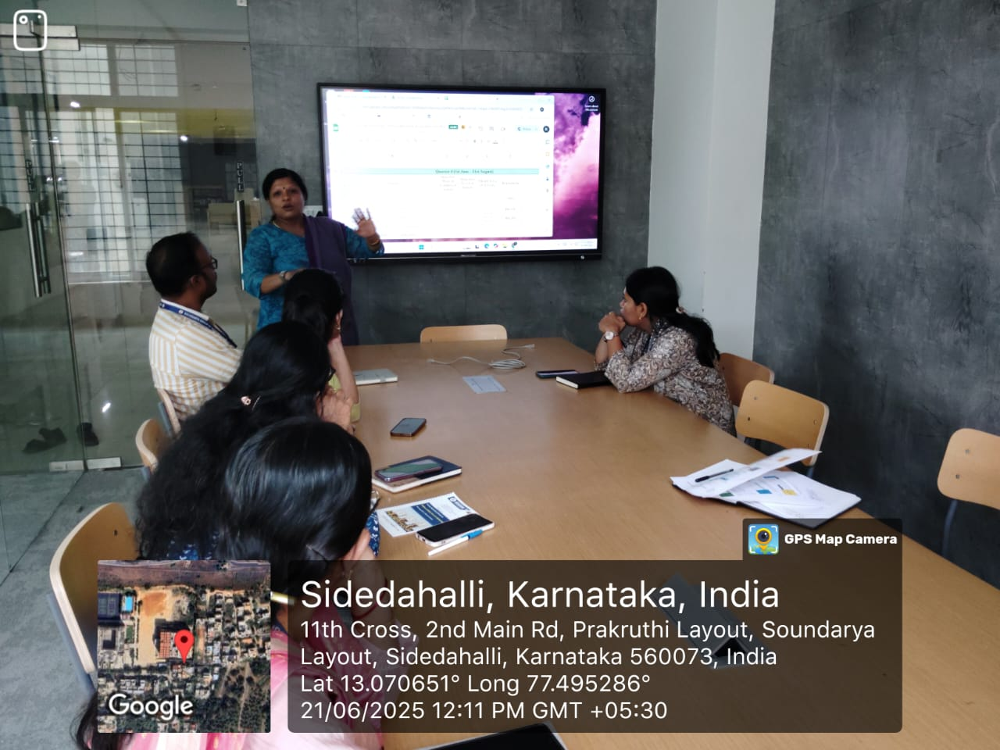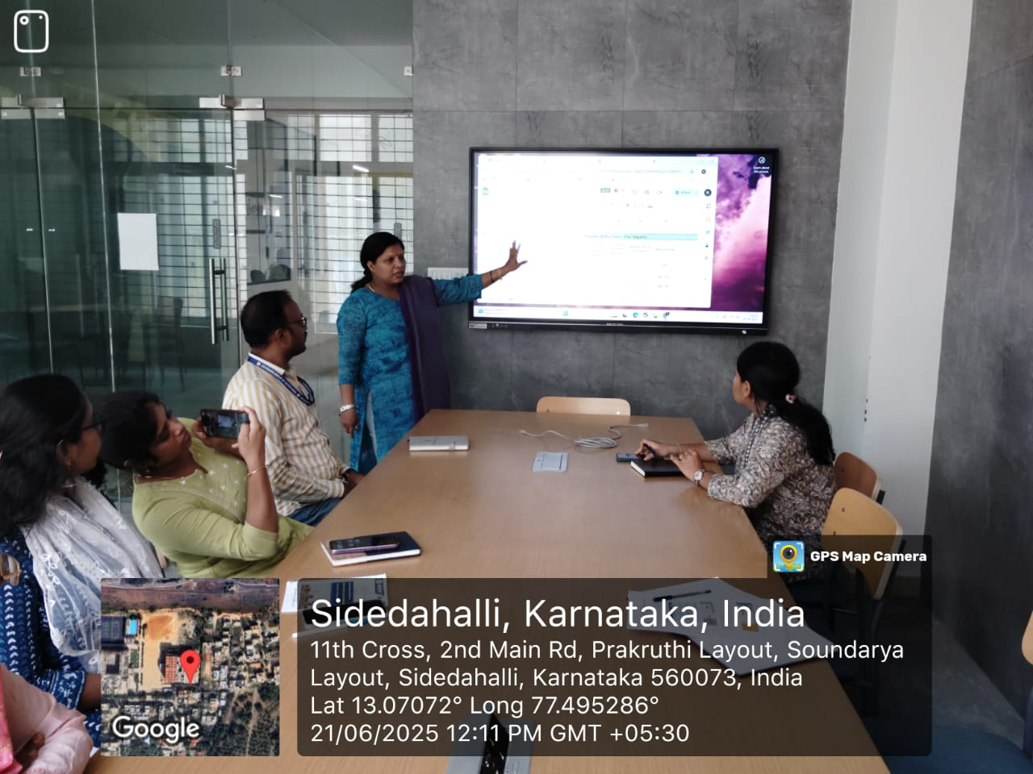

Quarter 4 - Sample Activities and Allocations:
Sl. No | Activity | Department
1 | Session on Innovation/Prototype Validation, “Value Proposition Fit” & “Business Fit” | MBA & BBA
2 | Session on Accelerators/Incubation – Early Stage Entrepreneurs | BBA
3 | Lean Start-up & MVP Mentoring Session | BCA & MCA
4 | Session on Angel Investment/VC Funding | BSc
5 | Panel Discussion with Innovation Ecosystem Enablers | BBA & BCA
6 | Outreach Program with ATL/SICs in Schools | B.Sc & B.Com
7 | Start-up Competition + Yukti Repository Submission | BBA
8 | Start-up Summit / Exhibition / Poster Presentations | BSc PS

IIC7.0 Calendar Activities for Academic Year 2024-25
1 | Innovation Day |  |  | BBA, MBA & BCA
2 | National Education Day |  |  | B.Sc FORENSIC SCIENCE
3 | National Entrepreneurship Day |  |  | BBA AND MBA
4 | National Science Day |  |  | B.Sc & B.Sc FORENSIC SCIENCE
5 | National Start-up Day |  |  | BBA & B.Sc FORENSIC SCIENCE
6 | National Youth Day |  |  | NSS/NCC
7 | National Energy Conservation Day |  |  | B.Sc & B.Sc FORENSIC SCIENCE
8 | National Pollution Control Day |  |  | B.Sc & B.Sc FORENSIC SCIENCE

Meeting Concluded at: 2:00 PM with a vote of thanks by the Convener, Dr. Roopa Shettigar.

